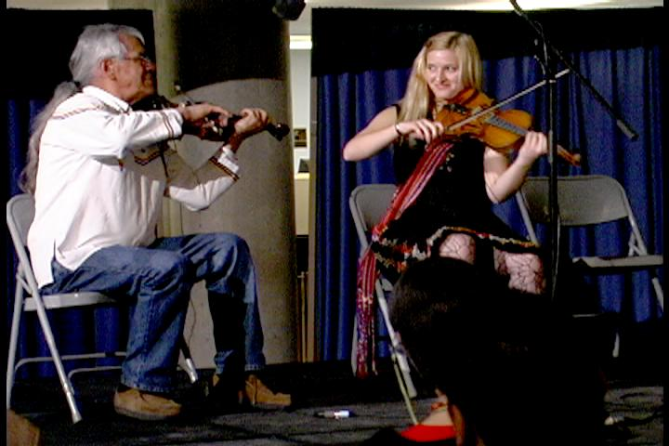
Fiddle Stories:
The Elder Youth Legacy Project

Fiddle Stories is a performing group of Aboriginal Elders and Youth drawn from across Canada.
Sponsored by the Métis Artists Collective in Ontario, Fiddle Stories is both a mentorship project and an exciting performance of old and uniquely Aboriginal forms of fiddle music. A repertoire and a style that developed in the early days of contact between Europeans and First Nations, the music is a true hybrid of the New and Old World. In danger of being lost forever, the purpose of Fiddle Stories is to pass on the oldest surviving traditions to a new generation of players, who will in turn, pass them on. In the 2008, this exciting cross-generational group will work together in concert.
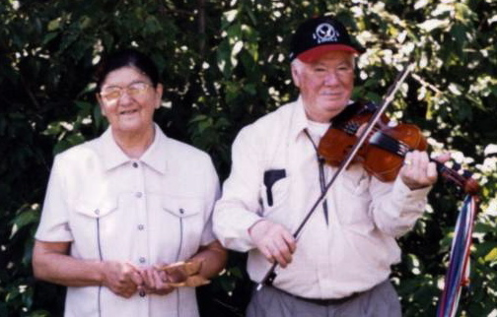

The Elders
James Cheechoo is from the Moose Cree First Nation in Moose Factory, Ontario, home to a unique style of fiddling which goes back to the arrival
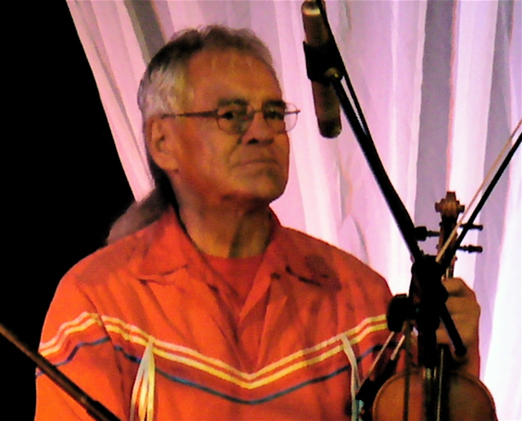
of Shay Chee Man (“Big Ship”), Hudson's Bay ships who brought Irish and Scottish fiddlers to the north. James is now recognized as the last of the "old-style" fiddlers in James Bay. Through his recordings and performances, James hopes to raise awareness of the old music and the story of the music as it reflects the history of the James Bay Cree. He performs with his wife Daisy on spoons and drum (See CD, Track #1). James and Daisy have performed at many Festivals throughout Canada, including 3 years at the Métis Arts Festival in Toronto (see Concert List). He has released one CD, Shay Chee Man.

Lawrence “Teddy Boy” Houle is from the Ojibwa community of Ebb and Flow, Manitoba, where he inherited the fiddle traditions of his family and his community, traditions which date back to the early days of the fur trade in Manitoba. Today, he is one few fiddlers in Manitoba who still maintain the old style and repertoire. He has been honoured over the years by being invited to many Canadian and International events, including Canada Day events in Toronto and Ottawa, Folk Festivals throughout Canada and the U.S, and a special honour -- the Native American Music Concert at Carnegie Hall in honour of 100th Anniversary of the Hall. He has released two CDs and appeared on Collections and Films of Aboriginal Music. (CD Track #2)

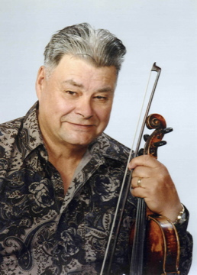
John Arcand is from Saskatchewan, has made fourteen recordings to date, and still plays and records the traditional Métis tunes of his Father and Grandfather as well as those he continues to research, learn and pass on. He is also a prolific writer having composed over 300 original tunes and has spent his life promoting and preserving the traditions of Métis Fiddle and Dance. he is founder of John Arcand Fiddle Fest, held annually on the second weekend of August, which celebrated its 10th anniversary in 2007. In 2003, he received the National Aboriginal Achievement Award and has performed for Queen Elizabeth and the President of Ireland.
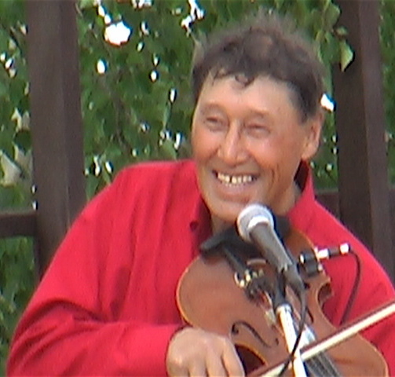
Colin Adjun is known as "The fiddler of the Arctic." He says he was born "with music in my head" and first learned to play when he was a young boy living out on the land. "My two uncles [Charlie Avakana and John Kuneyuk] played the fiddle, and they taught me when we were living in the outpost camp.” When he was nine years old, he was so enthusiastic about playing the instrument that he played when there was only one string. He has made three recordings of his fiddle music and has performed at many festivals, including Aklavik's Pokiak River Festival, Yellowknife's Folk on the Rocks, and Iqaluit’s Northern Arts Festival. (CD, Track #3)

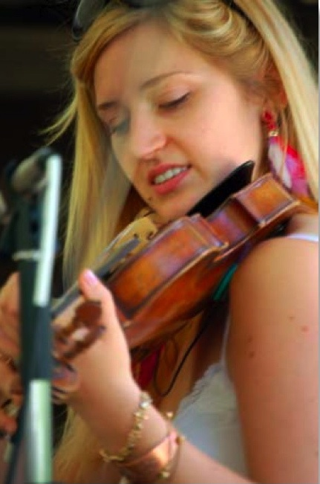

The Youth
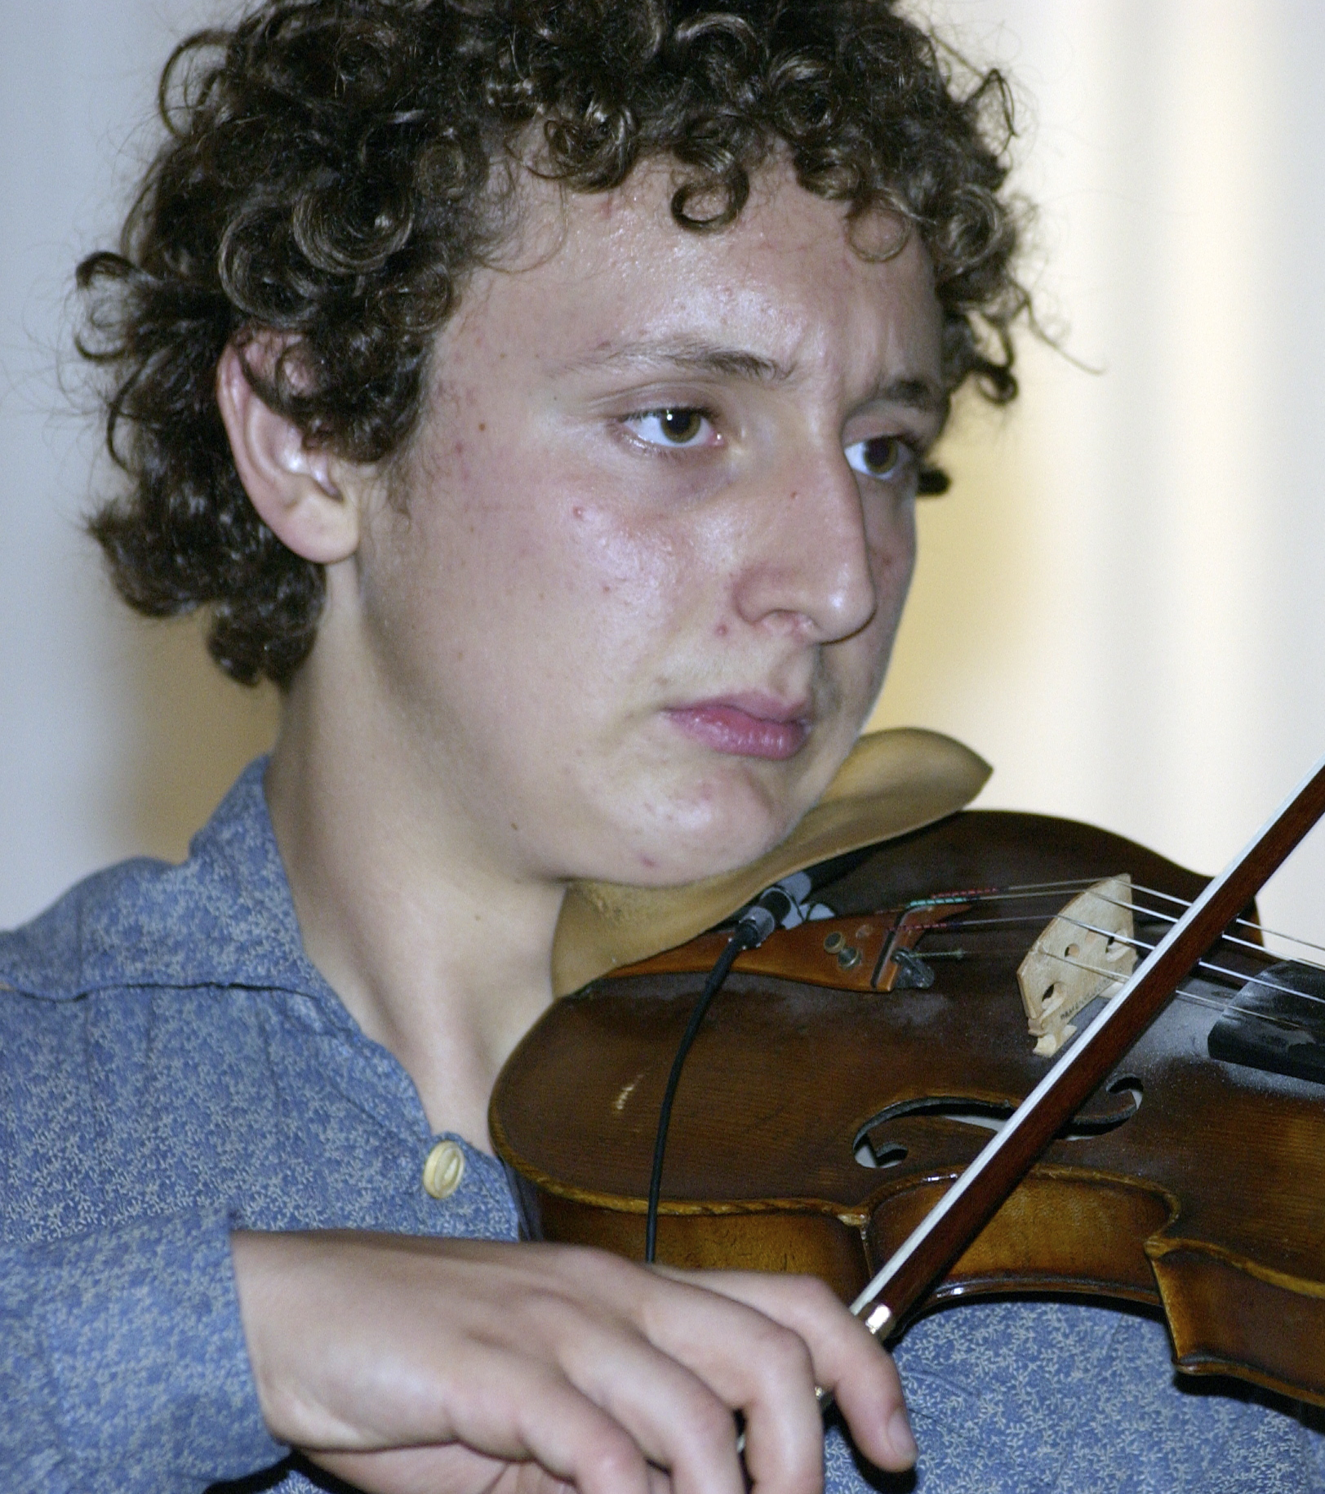
Alyssa Delbaere-Sawchuk: 21-year-old Alyssa began her musical studies at the age of 3 and is currently studying viola on scholarship in Switzerland. In 2004 she was awarded the National Métis Youth Role Model Award for Arts and Culture and since then, she has performed Métis music across the nation for various aboriginal events. In 2006, she received an Apprenticeship grant to study with Lawrence Teddy Boy Houle and recently released her first CD, Omeigwessi: A Tribute to Walter Flett.

Nicholas Delbaere-Sawchuk: Nicholas studies violin performance with Marie Berard in the Young Artists Performance Academy at the Royal Conservatory of Music. In 2004, he won Junior Strings Finalist Trophy at the Hamilton Kiwanis Music Festival, and In 2003, was featured Nicholas in the Vision TV production "Come Into the Parlour: A Student Recital." Nicholas studies Métis music with Anne Lederman, and performs with his brothers and sister in the Métis Fiddler Quartet.
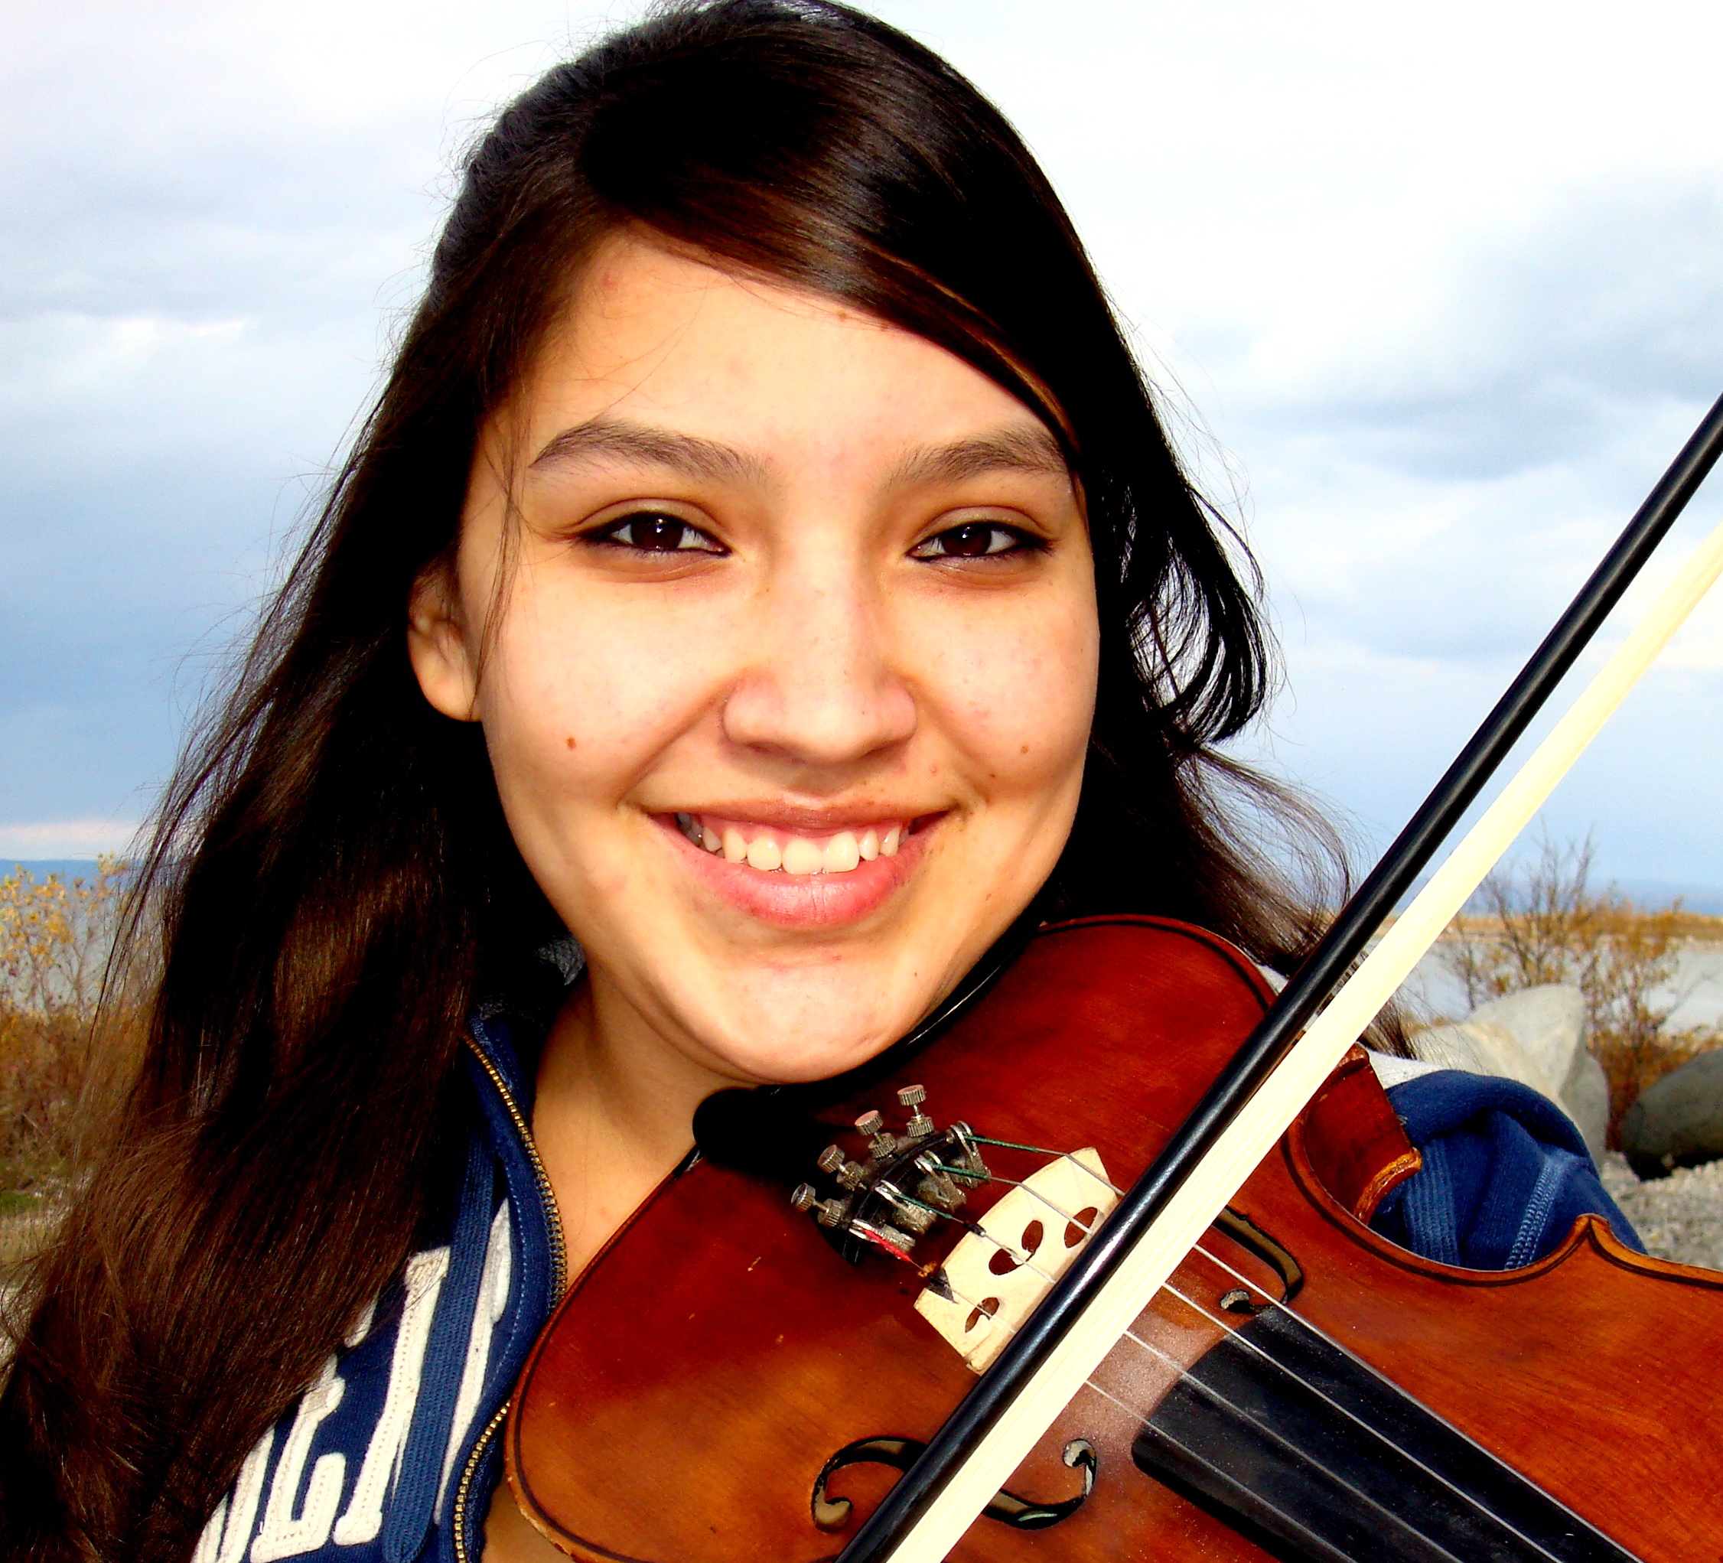
Ruby John: 17-year-old Ruby is an exceptionally talented young fiddler from Michigan who has studied classical music for several years with Chris Williams, and more recently, traditional fiddling with elder Lee Sloan, Anne Lederman and Mark Sullivan. Ruby is scheduled this upcoming year to play on the main stage at Spirit of the Woods, Springfield Celtic, Marshall Bluegrass, and the Kalkaska Bluegrass Michigan Music Festivals.

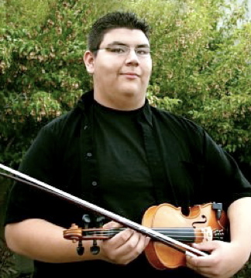
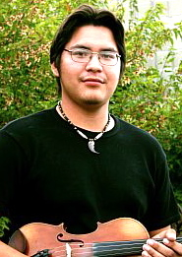
Ryan D’Aoust: 18-year-, Ryan D'Aoust, is from Norway House, Manitoba. A protegé of both John Arcand and Cameron Baggins, Ryan 's first CD, South Side of the Strings won the “Best Fiddle Album” category for the 2005 Canadian Aboriginal Music Awards, as well as the prestigious “CBC Galaxie Rising Star“ Award. In 2006, Ryan taught and performed at the Celtic Festival in Goderich, Ontario as well as the Grand Masters in Ottawa. He has now released his second CD, York Boats & Legends.

Matthew Contois: 19-year-old Matthew is from Grand Rapids, Manitoba and started learning fiddling at age 12 in the Frontier Fiddling Program. He has participated in numerous competitions, and square dances and now teaches the Frontier Fiddlers, as well as a fiddle program in Nelson House. In 2006, he was invited to the Grand Masters Fiddle Championship in Nepean, and, in 2007, he performed for the Métis pavillion at Folklorama in Winnipeg.

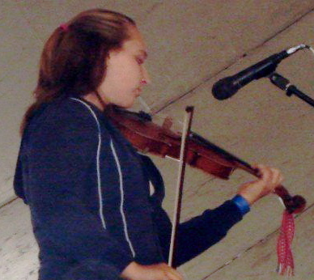
Alicia Blore: 15-year old Alicia has roots in Ste. Rose Manitoba where her great grandfather, Philip Zastre was a well-known Métis fiddler. She has been studying fiddle since she was 9 with Matthew Johnston, Mark Sullivan and Anne Lederman, as well as and competing in contests and attending camps such as Orangeville, the Grand Masters, the John Arcand Fiddle Fest and the Sturgeon Falls competition and camp.

Accompanists:
Daisy Cheechoo: Spoons and 2-sided skin drum have always been part of the James Bay tradition.

Jimmy Flett: On guitar, Jimmy has long been recognized as an outstanding musician in the Manitoba Arts community. Originally from Ebb and Flow, he is known for his ability to play anything from jazz to country to Metis "old-time" music and is the rhythmic backbone of the Ensemble.

Anne Lederman: On piano and guitar, Anne is also an important link to the older styles of fiddling in Manitoba and has taught several of the youth involved in the group. Having learned from elder fiddlers in Manitoba in the 1980s, she is now the only link to certain older Manitoba repertoires and will be passing some of that material on to the group.
CONTACT:
Anne Lederman, Artistic Director
153 Glendale Ave., Toronto, Ontario, M6R 2T4
PH: (416) 538 – 9036 E-Mail: anne.Lederman@sympatico.ca 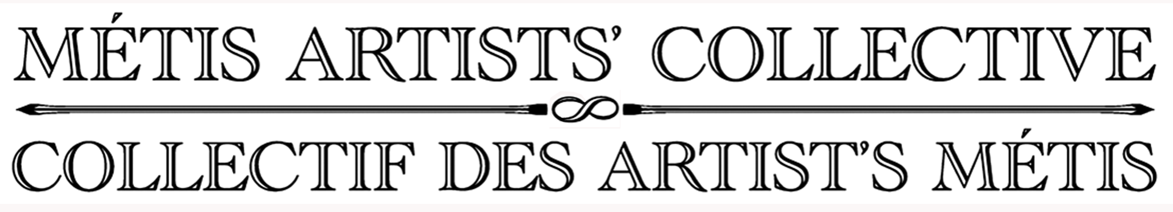

Career Highlights

James/Daisy Cheechoo
1999 International Fiddle Festival in Nova Scotia
2000 Seniors Jubilee at the Roy Thomson Hall, Toronto
2002 Special Guest at he John Arcand Métis Festival
2002 Featured in Telefilm Canada Documentary "How the Fiddle Flows".

"Teddy Boy" Houle
1982, 1983 Winnipeg Folk Festival, with the Red River Jiggers
1988 - 90 Vancouver Folk Festival and Mariposa Folk Festival, Barrie, Ontario
1992 Port Townsend American Fiddle Tunes Festival, Port Townsend, Washington
1994 Cultures Canada, Ottawa.. Canada Day Concert
1995 100 years of Carnegie Hall: Native American Music, Carnegie Hall, New York
1996-1997 North York Summer Strings: Fiddler in residence. Waldorf School, Toronto, Ontario
1997 “Medecine Fiddle” Documentary on Native fiddle traditions. Up North Films, Michigan
2002 East Lansing: Great Lakes Folk Music Festival, East Lansing, Michigan
2002 - 2007 Cypress Hills, Alberta: Métis Traditional Arts Camp: Back to the Hills

John Arcand
1999 Represent Western Canada at the Fiddles of the World, Halifax
2001 Delegate in an Irish/ Métis Cultural Exchange
2003 National Aboriginal Achievement Award for Arts and Culture
2003 Lifetime Achievement Award, Canadian Grand Masters Competition
2005 Lieutenant Governor’s Centennial Gala in Saskatoon. Queen Elizabeth II in attendance
2005 Saskatchewan Centennial Medal from the Province of Saskatchewan
2006 Cultural Diversity and Race Relations “Living in Harmony” Award, Saskatoon
2008 John is scheduled to receive The Order of Canada

Colin Adjun
2002 Great Northern Arts Festival in Inuvik, NWT
1992, 02, 07 Folk on the Rocks Festival, Yellowknife, NWT.
2007 Featured on Radio Nagasaki, Japan.
2007 Featured in a Special Program form the Glenbow Museum "Inusuvut: Our Way of Life"

Nicholas and Alyssa Delbaere-Sawchuk
2008 CD Release Concert, Feb. 14th, 2008. Hugh's Room Toronto
2007 Ontario Independent Music Awards Nomination, Best Folk
2007 Asham Stompers Dance Festival in Reedy Creek, Manitoba
2006 Métis Artists' Collective's Louis Riel Day, Celebrations at Toronto City Hall
2005 Toronto Harbourfront Centre Kick Up Your Heels Dance Festival
2003 National Métis Youth Awards Banquet, Canadian Museum of Civilization

Ryan D'Aoust
2005 Performed for Queen Elizabeth II and Prince Charles during trips to Winnipeg
2005-06 CAMA (Canadian Aboriginal Music Awards) and Aboriginal Peoples Choice Music Awards
2006 Performed by invitation at Canadian Grand Masters Fiddling Championship
2006 Won 17 and under fiddle competition at Festival du Voyageur and John Arcand Fiddle Fest
2007 Aboriginal Day Festival in Winnipeg

Matthew Contois
2006 Performed by invitation at the Grand Masters Fiddle Championship
2007 Performed at the Métis Pavillion, Folklorama in Winnipeg

Ruby John
2004 - 07 Brethren Spirit of the Woods Festival and West Michigan Bluegrass Festival, Lowell. Michigan
2006 Goulais River Bluegrass Festival, Ontario
2007 Springfield Celtic Festival, Fife Lake, MIchigan
2007 Traverse City Film Festival

Alicia Blore
2006 Placed 4th in Dorchester Fiddle Contest
2006 Performed in the Grand Finale of the Métis Arts Festival, Black Creek Village.

